WINFROG “F10” PRINTOUT CONFIGURATION SETUP

- PURPOSE
The purpose of this procedure is to detail the steps involved for all vessels to CONFIGURE the WINFROG F10 PRINTOUT.

- SCOPE
This procedure applies to all employees within the Organization.

- RESPONSIBILITY AND AUTHORITY
The Technical Director has the responsibility and authority for ensuring that this procedure is effectively implemented.

- Procedure

  - All work is done on the WINFROG main menu WINDOW. See Figure 1.

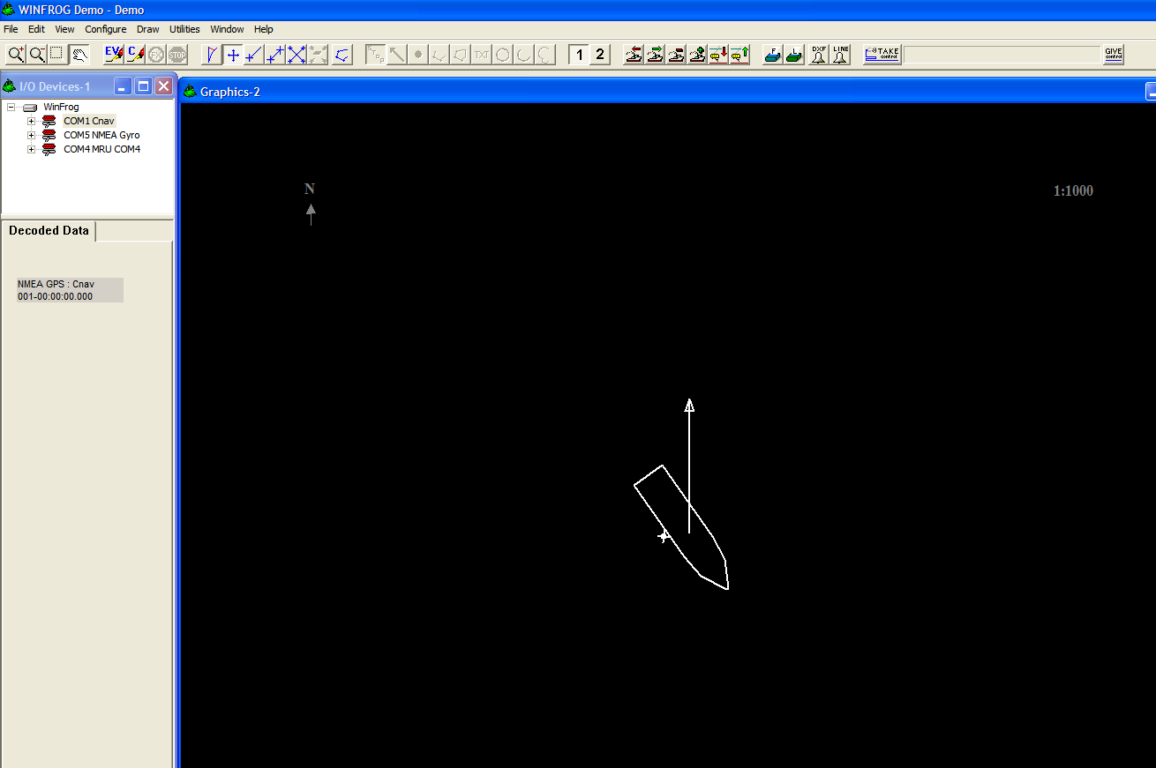
Figure 1

  - To select vehicle (s) to be printed out during F10, go to “CONFIGURE”, then “VEHICLES”. See Figure 2.

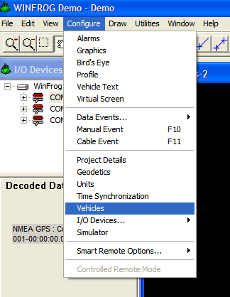
Figure 2

  - Left Click on selected Vehicles. The Vehicle will be highlighted in blue. See Figure 3.

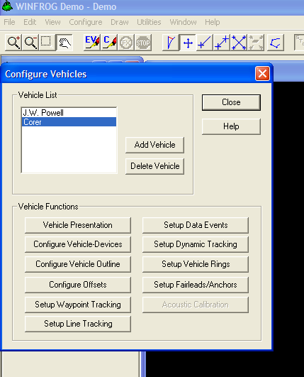
Figure 3

  - Select VEHICLE PRESENTATION. See Figure 4.

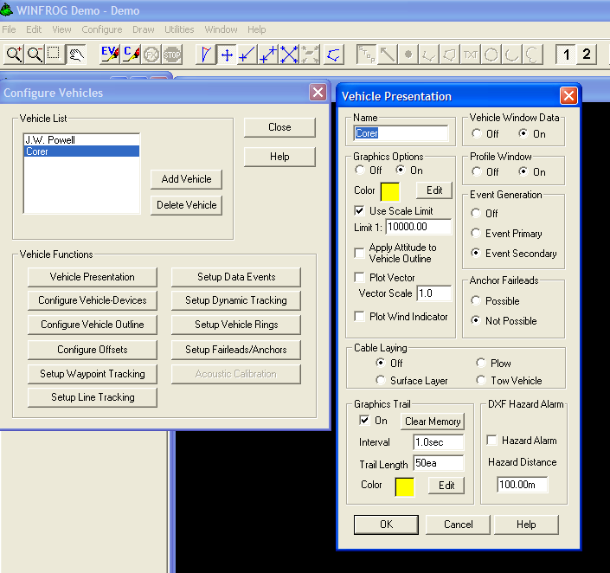
Figure 4

4.5 Use the “Event Generation” box to select where the vehicle text will be in the printout. If “OFF” is selected, the selected vehicle will NOT be printed during F10.

  - To Turn ON or OFF the very top header of the F10 printout,(Company Name, Project Number, etc) select “FILE”, “PRINTER SETUP”. The “PRINTER CONTROL” window will pop up. See Figure 5 and 6..

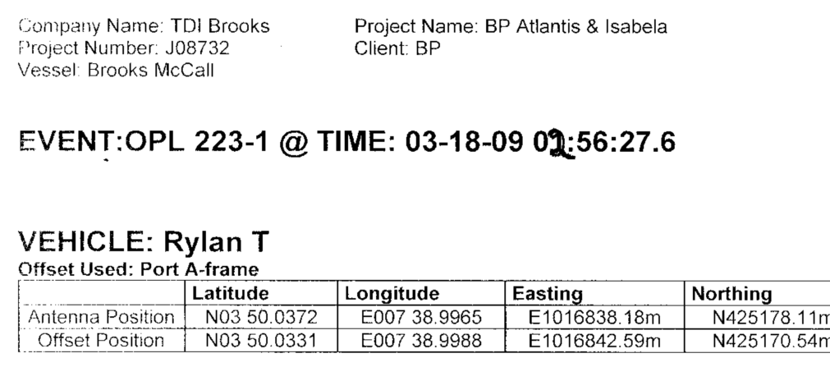
Figure 5

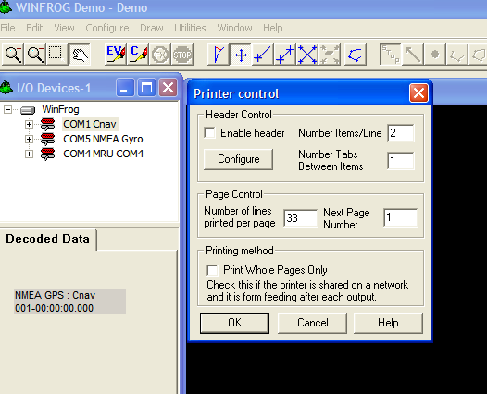
Figure 6

  - You can turn ON or OFF by selecting ( click on/off) the ‘ENABLE HEADER” selection.
  - If you wish to change the various lines to be printed out on the header, select the “CONFIGURE” button, and make selections there. See Figure 7.

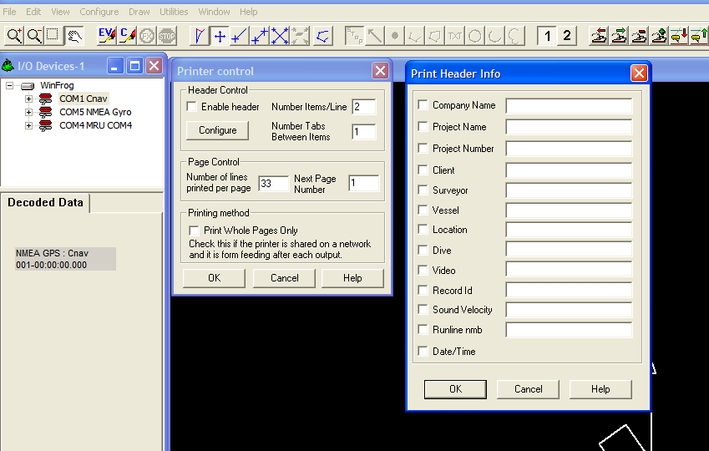
Figure 7

4.9 Click “OK” to close out the windows and to save your changes.

- RELATED DOCUMENTATION

- Revisions

Section | Description | Date | Approved by:
 | Initial Release | 18MAR09 | J. Brandesky

